Granny Grommet and Me | Watch https://www.youtube.com/watch?v=uWiCN5VP5Gs about Granny Grommets in real life.
Term 3, Week 3

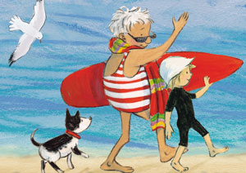
Name:
Year 2: EN1-8B
Granny Grommet and Me:
CBCA shortlist 2014

Authors often dedicate their book to someone who has inspired them or supported them. Dianne Wolfer dedicated this book to her mum and the Granny Grommets in Albany, WA.

If you wrote a book who would you dedicate it to?

Why would you choose that person?

Name:
Year 3: EN2-7B
Granny Grommet and Me:
CBCA shortlist 2014

Alliteration is when a writer uses same consonant sounds at the beginning of words that occur close together. Dianne Wolfer uses alliteration to make the text come alive. For example she writes "Doris ducks and dives". We can picture Doris moving quickly from side to side in the water.
Make up some alliteration for the following names. Try to keep the theme to what they could do in the sea or at the beach. Add extra names you can think of.
Belinda
Dominic
Mia
Sam

Name:
Year 4: EN2-3A
Granny Grommet and Me:
CBCA shortlist 2014

You are going to spend a couple of weeks creating a sign for Book Week.
The first thing you need to do is find an image that relates to the book you were given.
You will use this link to look for images. You MUST use this link as we are looking for pictures that you are allowed to reuse for noncommercial use (that means you aren't going to make money from someone else's picture).
Put words that relate to the picture in the search box and find an image that you like.
Click on the image TWICE. The click on VISIT PAGE.
Paste the URL in this box:

Now right click on the picture and choose SAVE AS. Name it STRIX and save it in your file under my pictures .
Job one is done!
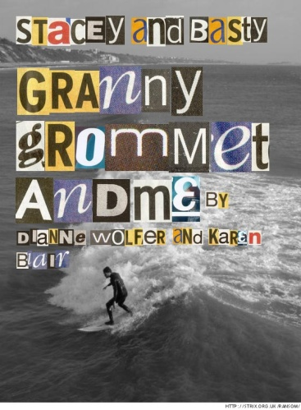
Now you are going to make a poster using a new technology tool. My example is on the right.
Click here to access Strix.
Make the title your names.
In the next box, put in the title of the book with [[ ]] around each word. Add the author and illustrator. So I put [[Granny]] [[Grommet]] [[and]] [[Me]] by Dianne Wofer and Karen Blair
Click UPDATE TEXT.

Scroll down to where the upload button is. Add a picture from your computer by clicking on BROWSE and going to the file where you stored the picture you found. When you come back to strix click on upload.
Then click on the bit at the bottom that says it's to merge it.
Your image will come up. RIGHT click on the picture and choose SAVE AS. SAVE it on student share, your class, student group work, strix by your names.

Marking rubric:

One is best! | 1 | 2 | 3
Got a picture with creative commons labelled for noncommercial reuse.
Put the link to the picture in the box above.
SAVED the picture in the right location with the right name.
The picture really captures the spirit of the book.
The Strix is done properly with your names at the top and the title put in with the double square brackets.
There are no spelling errors.
You saved it by the correct name in the correct place.
You completed a STRIX

