Synthesise
Analyse and synthesise the information and apply it to the task, making links between existing and new knowledge and construct evidence based arguments.
What are the key ideas? What does it all mean?
What are the links and themes emerging across the information?
Is this information answering the task?
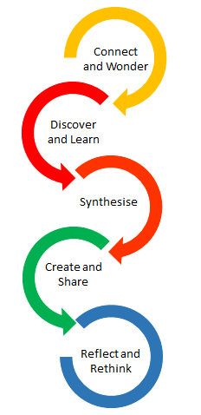
What do I still need to find out?
What are my conclusions, decision, opinions etc?
This step may involve:
- Analyse and synthesise the information and apply it to the task
- Making links between existing and new knowledge
- Constructing evidence based arguments.
- Proposing actions, implications, solutions

